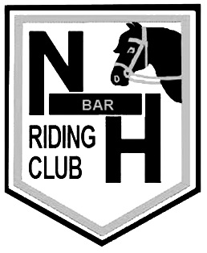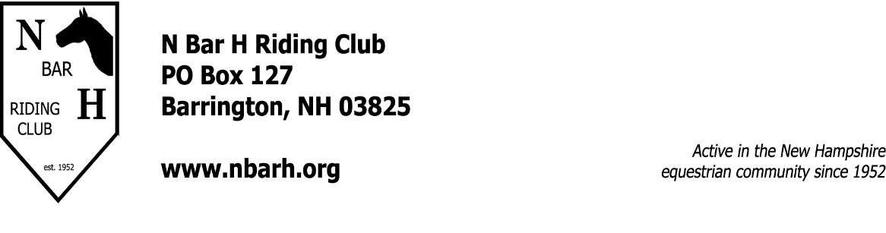
Year End Award Sponsorships
Year End awards are presented to competitors in each of our three show divisions, Gymkhana, Miniatures, and Pleasure. The awards are presented at the annual Awards Banquet held in the fall after season has concluded. These awards recognize a wide variety of accomplishments within the specific divisions, a particular breed or age, across shows, and much more. Awards can be in honor or memory of a horse, rider, barn, event, or for anything that is meaningful to the sponsor. The sponsorship is for one (1) year, and can be renewed annually. Please also let us know if you would like to remain anonymous.
Awards are usually in the form of a trophy, plaque, or practical, but is really only limited to your imagination. If you need assistance in defining what you would like to do, feel free to contact any of the board members who will be happy to assist you.
NAME OF AWARD: ________________________________________________________
AWARD SPECIFICS: ________________________________________________________
_______________________________________________________
Name: ________________________________
Address: _____________________________
______________________________
Phone: _______________________________
Email: ________________________________

Please return this form and a check made out to N Bar H to: Patty Milano, 224 Stagecoach Road, Barrington, NH, 03825

OFFICE USE ONLY:

Check #:________ Amount:________ Received by:_________________ Date:___________

